**Introductory Concepts**

Electronic circuits can be divided into two broad categories, digital and analog. Digital electronics involves quantities with discrete values, and analog electronics involves quantities with continuous value.

**Digital and Analog Quantities**

An analog quantity is one having continuous values. A digital quantity is one having a discrete set of values. Most things that can be measured quantitatively occur in nature in analog form. For example, the air temperature changes over a continuous range of values. During a given day, the temperature does not go from, say, 70­ to 71­ instantaneously; it takes on all the infinite values in between. If you graphed the temperature on a typical summer day, you would have a smooth, continuous curve similar to the curve in Figure 1–1. Other examples of analog quantities are time, pressure, distance, and sound.

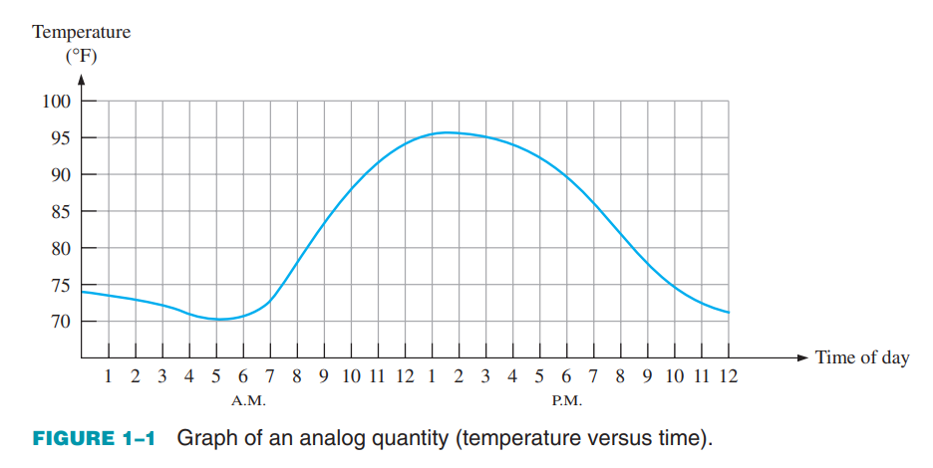

Rather than graphing the temperature on a continuous basis, suppose you just take a temperature reading every hour. Now you have sampled values representing the temperature at discrete points in time (every hour) over a 24-hour period, as indicated in Figure 1–2.

You have effectively converted an analog quantity to a form that can now be digitized by representing each sampled value by a digital code. It is important to realize that Figure 1–2 itself is not the digital representation of the analog quantity.

**The Digital Advantage**

Digital representation has certain advantages over analog representation in electronics applications. For one thing, digital data can be processed and transmitted more efficiently and reliably than analog data. Also, digital data has a great advantage when storage is necessary. For example, music when converted to digital form can be stored more compactly and reproduced with greater accuracy and clarity than is possible when it is in analog form. Noise (unwanted voltage fluctuations) does not affect digital data nearly as much as it does analog signals.

**State two advantages of the transmission of data in digital, rather than analogue, form:**

**Better Quality over Distance:** Digital signals can travel longer distances without losing quality, making them more reliable for communication across networks compared to analog signals.

**Flexibility and Multifunctionality:** Digital signals can carry various types of information, including text, audio, images, and video, using the same underlying technology.

**Digital:**

**Precision and Accuracy:** Digital systems excel in providing high precision and accuracy. The discrete nature of digital signals allows for exact representation and manipulation of numerical values, minimizing errors during processing.

**Signal Processing and Storage:** Digital signals are well-suited for signal processing, manipulation, and storage.

**Noise Immunity:** Digital signals are generally more immune to noise and interference.

**Examples:**

1. **Digital Audio Processing:**
   * **Example:** MP3 players, where digital signals represent and process audio data with high precision, allowing for various features like equalization and volume control.
2. **Digital Communication Systems:**
   * **Example:** Mobile phones use digital signals for voice and data transmission, enabling clear communication and data transfer with error correction.

**Analog:**

1. **Continuous Representation:** Analog signals represent a continuous range of values.
2. **Real-world Signals:** Many natural phenomena, like sound and light, are inherently analog. Analog systems are often used in applications where direct interaction with the real-world environment is necessary.
3. **Simplicity in some applications:** Analog systems can be simpler in certain applications where the precision of digital representation is not required. For example, some simple sensors and control systems can operate effectively in the analog domain.

**Examples:**

1. **Analog Audio Amplification:**
   * **Example:** Analog amplifiers in audio systems, where continuous analog signals from sources like turntables are amplified to drive speakers and produce sound.
2. **Analog Temperature Sensors:**
   * **Example:** Analog temperature sensors that provide a continuous voltage or current output proportional to the temperature, commonly used in climate control systems.

**Summary of Differences:**

* **Representation:** Digital uses discrete values (bits), while analog uses continuous signals.
* **Precision:** Digital offers high precision, whereas analog is subject to limitations in precision.
* **Processing:** Digital systems excel in algorithmic processing, while analog systems are suitable for continuous and real-time processing.
* **Noise Immunity:** Digital signals are less sensitive to noise, while analog signals are more susceptible.

**Analog-to-digital conversion (ADC)**

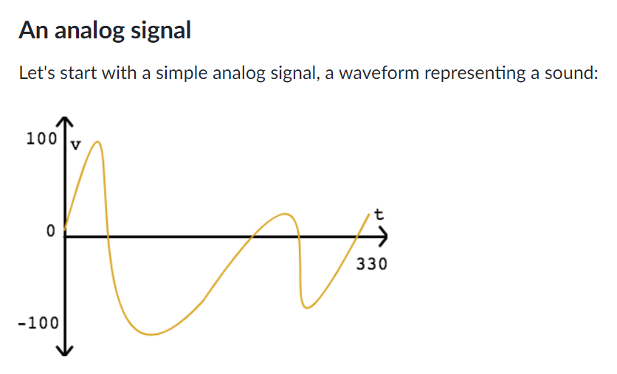

All analog signals are continuous both in the time domain (x-axis) and in the amplitude domain (y-axis).

**Sampling (x-axis)**

The first step is **sampling**, where we take a sample at regular time intervals. This step reduces the continuous time domain into a series of discrete intervals. Take a sample at every curve/interval for more precision.

In this signal, where time varies from 0 to 330 milliseconds, we could take a sample every 30 milliseconds:

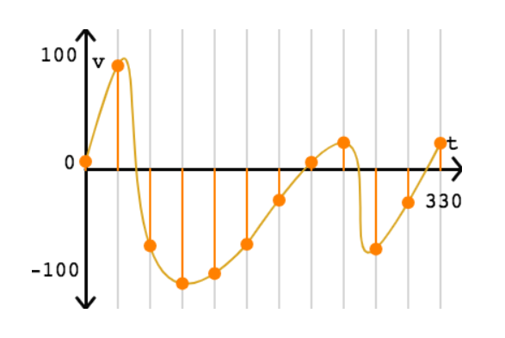

That gives us 12 samples of the signal between 0 and 330 milliseconds.

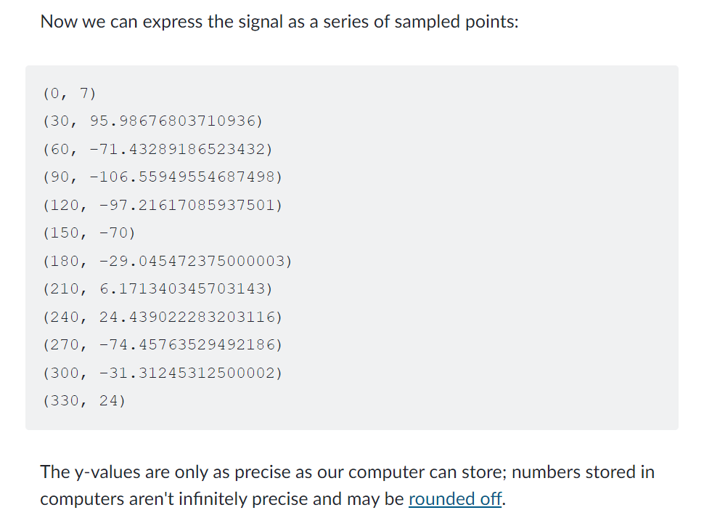

**Quantization (y-axis)**

After sampling, we are still left with a wide range in the amplitude domain, the y values. The next step of quantization reduces that continuous amplitude domain into discrete levels.

For our simple signal, where amplitude varies from -100 to 100 volts, we can apply a quantization interval of 25 volts:

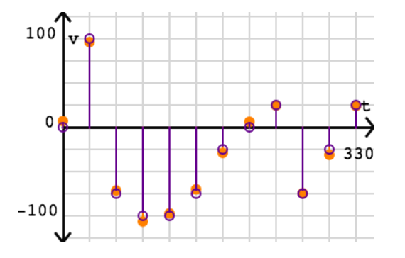

**Ladder Form:**





The quantizing step always introduces some amount of quantization error, which is measured by comparing the actual signal value with the quantized value at each sampled point.

**Reconstruction**

We often store analog signals in digital storage so that we can reproduce them later, like playing back an audio file or displaying an image. When a device wants to convert a digitized signal back into an analog signal, it will attempt to reconstruct the original continuous signal.

For this signal, a simple reconstruction strategy could interpolate a smooth curve through the quantized points:

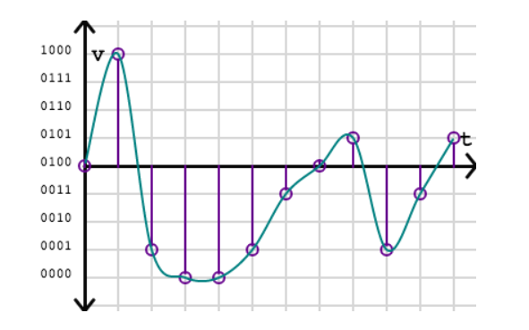

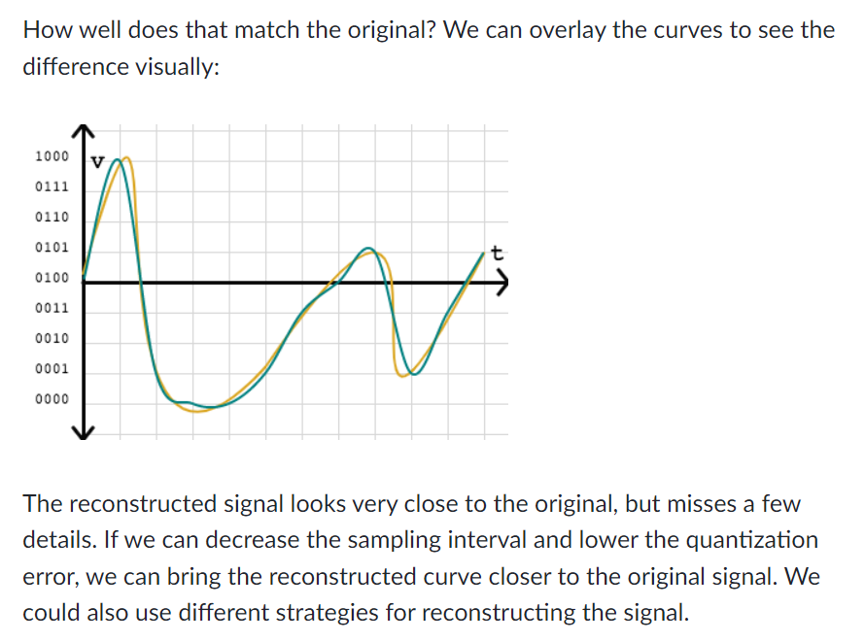

**Mechatronics**

Mechatronics is a multidisciplinary field that combines mechanical engineering, electronics, computer science, and control engineering to design and create intelligent systems and products. These systems are used to achieve automation and smart functionalities.

**Examples**

Robot arms, conveyor belts, Programming to guide robots, Automated assembly lines for efficient production, Heating or cooling system, Temperature sensors, and Gyroscopes for stability.

**A system that uses both Analog and Digital Quantity**

**Digital Camera Imaging System**

Imagine a digital camera as a system that takes pictures.

1. **Analog Part (Capturing Light):**
   * **Function:** The camera's "eye" (image sensor) sees and measures the light in a smooth way.
   * **Nature:** It uses continuous signals to represent the varying light levels in the scene.
2. **Digital Part (Processing the Picture):**
   * **Conversion:** The camera turns the smooth light measurements into numbers (digital signals) using a converter.
   * **Processing:** The camera's brain (image processor) uses these numbers to make the picture look better by fixing colors, reducing noise, and compressing the image.
3. **How They Work Together:**
   * The analog part captures the initial picture with smooth variations in light.
   * The digital part converts and improves the picture using numbers.
   * The final result is a digital image that can be stored on your camera, shown on a screen, or sent to others.

**Give an example of a system that is analog and one that is a combination of both digital and analog. Name a system that is entirely digital.**

**Analog System: Analog Clock**

* **Description:** An analog clock is a classic example of an analog system. The movement of the clock hands represents time continuously, with no discrete steps. The position of the clock hands smoothly changes as time progresses.

**Mixed-Signal System: Smart Home Thermostat**

* **Description:** A smart home thermostat is a mixed-signal system. It uses analog temperature sensors to continuously measure the room's temperature. The digital control unit processes this information and digitally adjusts the heating or cooling systems. The actual temperature change, implemented through the heater or air conditioner, involves analog elements.

**Entirely Digital System: Digital Wall Clock**

* **Description:** A digital wall clock is entirely digital. It displays time using discrete numerical digits, with no moving hands. The time is processed digitally, often using a quartz crystal oscillator. All functions, including setting the time and triggering alarms, are managed digitally. The displayed time changes in distinct increments, making it a purely digital representation of time.

**Quantization**

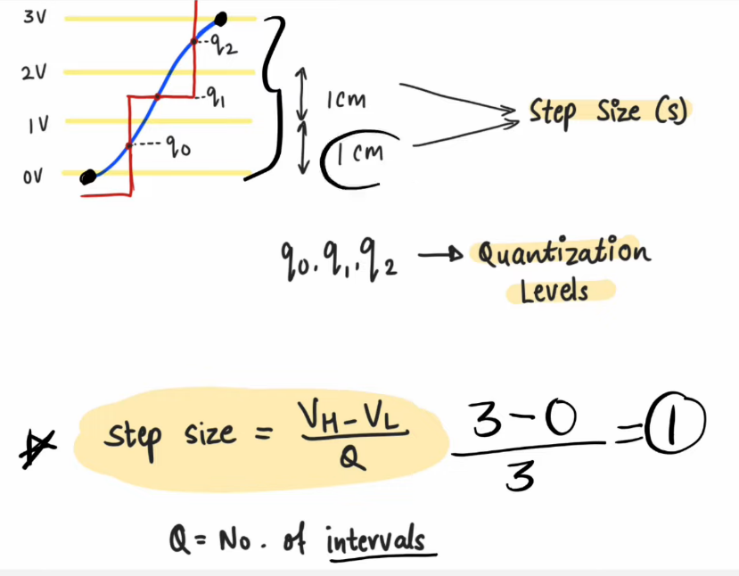 VH = High Voltage

VL = Low Voltage



